Thursday, Mar 19, 2026
Spring Seminar - Adonai
Shea Monihan

Rising to the Occasion

Atar h6279, h6280, h6282, h6283
To burn incense in worship, to intercede, pray, entreat, supplicate
Incense (as increasing to a volume of smoke) Abundant, Multiply

Offered on behalf of a promise, vow, or assignment from God in the Selah
Connected with the m’nuwchah - the continuing and abiding place of the breath of God

~~~~~~~~~~~~~~~~~~~~~~~~~~~~~~~~~~~~~~~~~~~~~~~~~~~~~~~~~~~~~~~~~~~~~~

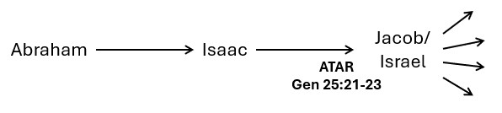
First Issuance
-

Beginnings

Genesis 25:21-23
And Isaac intreated the LORD for his wife, because she was barren: and the LORD was intreated of him, and Rebekah his wife conceived. ²² And the children struggled together within her; and she said, If it be so, why am I thus? And she went to enquire of the LORD. ²³ And the
LORD said unto her,
Two nations are in thy womb, And two manner of people shall be separated from thy bowels; and the one people shall be stronger than the other people; and the elder shall serve the younger.

Job 22:27 Eliphaz
Thou shalt make thy prayer unto him, and he shall hear thee, and thou shalt pay (salam - peace) thy vows.

Ezekiel 35:13-14
Mount Seir - Esau’s territory
Thus with your mouth ye have boasted against me, and have multiplied your words against me: I have heard them. ¹⁴ Thus saith the Lord (Adonai) GOD (Yahweh); When the whole earth rejoiceth, I will make thee desolate.

Transitional Moments
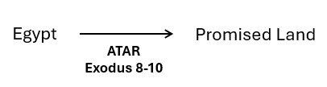

Exodus 7 - 12
- Water to Blood
Know that I am the LORD
- Frogs - Pharaoh asks Moses to intreat the LORD to take away the frogs (Ex 8:8-15)
Know that there is none like unto the LORD our God
- Lice
- Flies - Pharaoh asks Moses to intreat that flies may depart (Ex 8:28) Know that I am the LORD in the midst of the earth
- Disease on livestock
- Boils
- Thunder, Hail and Fire - Pharaoh asks Moses to intreat the LORD that there be no more mighty (elohim) thunderings and hail (Ex 9:28) Know that the earth is the LORD’s
- Locusts - Pharaoh asks Moses to intreat the LORD your GOD (Ex 10:17)
- Darkness
- Death of Firstborn

Isaiah 19:21-22
And the LORD shall be known to Egypt, and the Egyptians shall know the LORD in that day, and shall do sacrifice and oblation; yea, they shall vow a vow unto the LORD, and perform (salam - peace) it.
²² And the LORD shall smite Egypt: he shall smite and heal (rapha) it: and they shall return even to the LORD, and he shall be intreated of them, and shall heal (rapha) them.

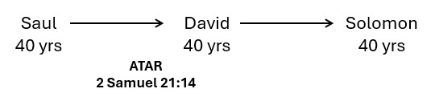

2 Samuel 21:14
And the bones of Saul and Jonathan his son buried they in the country of Benjamin in Zelah, in the sepulchre of Kish his father: and they performed all that the king commanded. And after that God was intreated for the land.

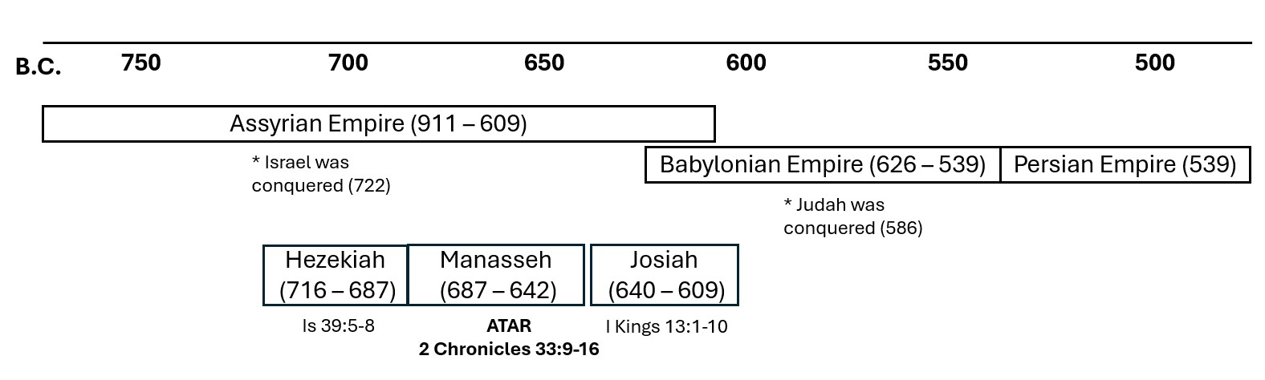

2 Chronicles 33:9-17
So Manasseh made Judah and the inhabitants of Jerusalem to err, and to do worse than the heathen, whom the LORD had destroyed before the children of Israel. And the LORD spake to Manasseh, and to his people: but they would not hearken.
¹¹ Wherefore the LORD brought upon them the captains of the host of the king of Assyria, which took Manasseh among the thorns, and bound him with fetters, and carried him to Babylon. ¹² And when he was in affliction, he besought the LORD his God, and humbled himself greatly before the God of his fathers, ¹³ And prayed (palal) unto him: and he was intreated of him, and heard his supplication (tehina), and brought him again to Jerusalem into his kingdom. Then Manasseh knew that the LORD he was God.

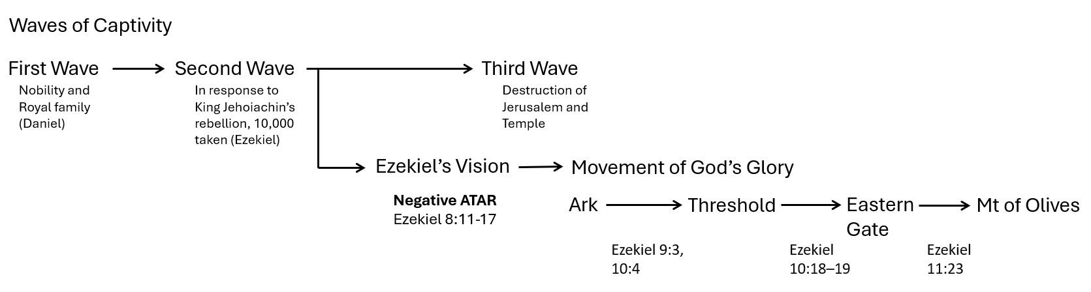

Ezekiel 8:7-17
And he brought me to the door of the court; and when I looked, behold a hole in the wall. ⁸ Then said he unto me, Son of man, dig now in the wall: and when I had digged in the wall, behold a door. ⁹ And he said unto me, Go in, and behold the wicked abominations that they do here. house of Israel do in the dark (hosek), every man in the chambers of his imagery? for they say, The LORD seeth us not; the LORD hath forsaken the earth.

¹³ He said also unto me, Turn thee yet again, and thou shalt see greater abominations that they do. ¹⁴ Then he brought me to the door of the gate of the LORD's house which was toward the north; and, behold, there sat women weeping for Tammuz.

¹⁵ Then said he unto me, Hast thou seen this, O son of man? turn thee yet again, and thou shalt see greater abominations than these. ¹⁶ And he brought me into the inner court of the LORD's house, and, behold, at the door of the temple of the LORD, between the porch and the altar, were about five and twenty men, with their backs toward the temple of the LORD, and their faces toward the east; and they worshipped the sun toward the east.

¹⁷ Then he said unto me, Hast thou seen this, O son of man? Is it a light thing to the house of Judah that they commit the abominations which they commit here? for they have filled the land with violence, and have returned to provoke me to anger: and, lo, they put the branch to their nose. ¹⁸ Therefore will I also deal in fury: mine eye shall not spare, neither will I have pity: and though they cry in mine ears with a loud voice, yet will I not hear them.

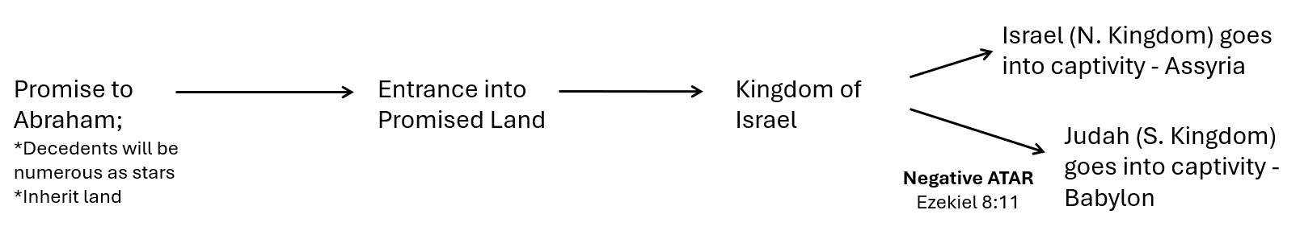

Lord (Adonai) GOD (Yahweh) - First usage Gen 15:2,8 Abram calls on Lord GOD
210/295 usages are in Ezekiel

Establishment of the M’nuwchah

Judges 13:1-2, 8-9
And the children of Israel did evil again in the sight of the LORD; and the LORD delivered them into the hand of the Philistines forty years. ² And there was a certain man of Zorah, of the family of the Danites, whose name was Manoah; and his wife was barren, and bare not…….. ……………..⁸ Then Manoah intreated the LORD, and said, O my Lord, let the man of God which thou didst send come again unto us, and teach us what we shall do unto the child that shall be born. ⁹ And God hearkened to the voice of Manoah; and the angel of God came again unto the woman as she sat in the field: but Manoah her husband was not with her.

2 Samuel 24:24-25
And the king said unto Araunah (Ornah), Nay; but I will surely buy it of thee at a price: neither will I offer burnt offerings unto the LORD my God of that which doth cost me nothing. So David bought the threshingfloor and the oxen for fifty shekels of silver. ²⁵ And David built there an altar unto the LORD, and offered burnt offerings and peace offerings. So the LORD was intreated for the land, and the plague was stayed from Israel.

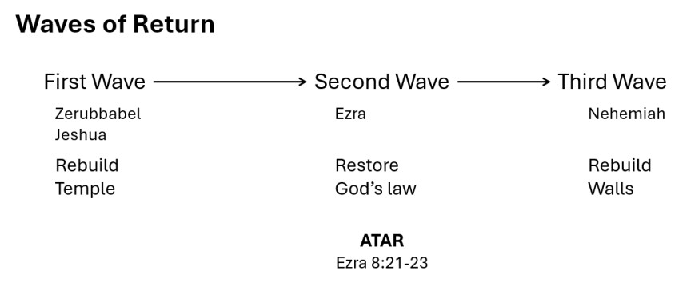

Ezra 8:21-23
Then I proclaimed a fast there, at the river of Ahava, that we might afflict ourselves before our God, to seek of him a right way for us, and for our little ones, and for all our substance. ²² For I was ashamed to require of the king a band of soldiers and horsemen to help us against the enemy in the way: because we had spoken unto the king, saying, The hand of our God is upon all them for good that seek him; but his power and his wrath is against all them that forsake him.
²³ So we fasted and besought our God for this: and he was intreated of us.

Bringing to completion

Jeremiah 33:6-7
Behold, I will bring it health (arukah - restoration) and cure (marpe), and I will cure (rapha) them, and will reveal (gala - uncover, open) unto them the abundance of peace (shalom) and truth (emet). ⁷ And I will cause the captivity of Judah and the captivity of Israel to return, and will build them, as at the first.

So I went in and saw; and behold every form of creeping things, and abominable beasts, and all the idols of the house of Israel, pourtrayed upon the wall round about. ¹¹ And there stood before them seventy men of the ancients of the house of Israel, and in the midst of them stood Jaazaniah the son of Shaphan, with every man his censer in his hand; and a thick cloud of incense went up. ¹² Then said he unto me, Son of man, hast thou seen what the ancients of the

